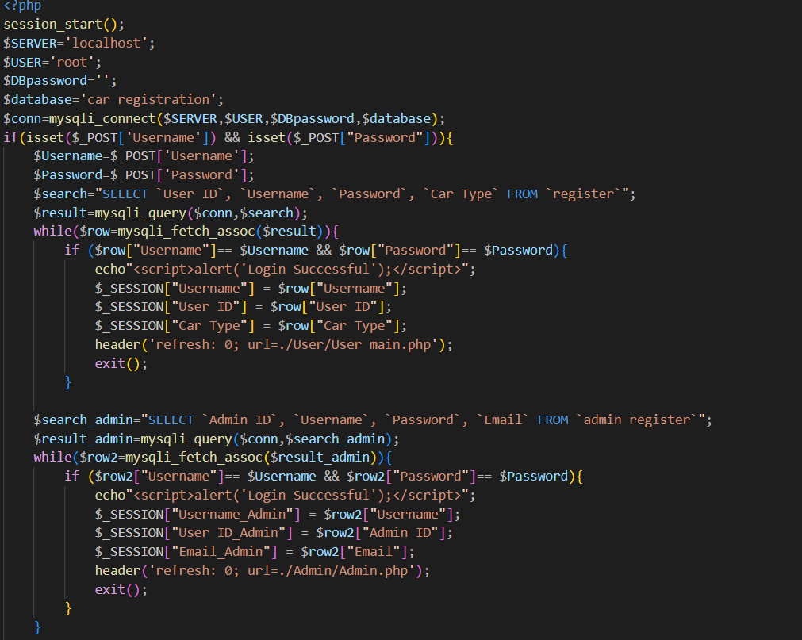

This is the source code for the login page. To keep the user's personal information in the session and share it with another PHP page, we must first initiate the session. We will utilise PHP's $Post[] function to retrieve the user input once we have obtained it via the post method from the HTML input tag. We have two databases that separately hold the data so that we can make sure the user is accessing the proper pages. They are the admin and the user, respectively. The username and password will be compared by the system to the information stored in the database. The system will switch to the other table, which contains the admin data, if it is unable to distinguish between the username and password in the user table. Upon successful discovery, it will switch to the designated pages and terminate the loop.

When the user logout the pages, this code is use for destroying all the value that store in Session. It can prevent the other user login but the sessions still storing the previous user information. After that will bring the user to our Home page. Also, if user need to Switch Account, it also will implement the code same with logout, but the direction that bring is different.

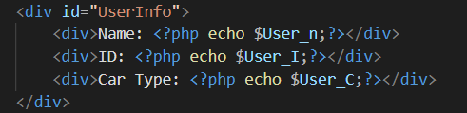

This section is used on all webpages and displays all user data. The function $_session[] calls the variable from different login pages and determines if it is set or not. Simply leave the value blank if it is not set. It can steer clear of PHP errors on webpages. In addition, the html tag appears if necessary. The middle PHP tag must be opened.

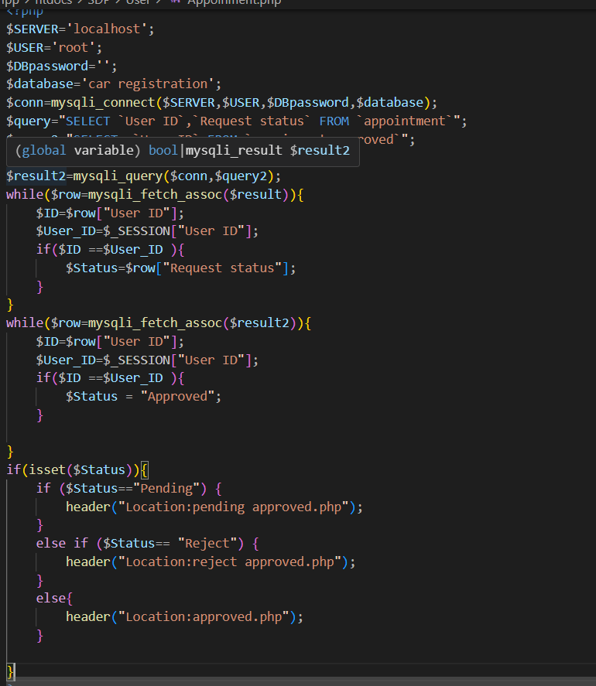

For the appointment part, the system needs to find out whether the user is haven’t appointment, pending or reject. For this issue, we come out the solution is check select the payment status from appointment part that same with the user currently login. After that check if status Is pending then display pending pages, else if Reject that show reject pages and else approved pages.

